**8.1 Fluid Mosaic Model**

General Membrane Structure and Function

* Protect the interior of the cell from the external environment
* Selectively regulate traffic into and out of the cell
* Involved in both intracellular and intercellular communication and transport

Membrane Dynamics

* Membrane is **not static**
* Lipids move freely in the plane of the membrane via simple diffusion, and can assemble into lipid rafts
* Flippases are specific membrane proteins that maintain the bidirectional transport of lipids between the layers of the phospholipid bilayer in cells
* Proteins and carbohydrates may also move within the membrane, but are slowed by their relatively large size

**8.2 Membrane Components\***

Lipids

1. Fatty Acids and Triacylglycerols
2. Phospholipids
3. Sphingolipids
4. Cholesterol and Steroids
5. Waxes

Proteins

1. Integral proteins
   1. Transmembrane (pass completely through the lipid bilayer)
   2. Embedded (associated with only the interior or exterior surface of the cell membrane)
2. Membrane-associated (peripheral) proteins

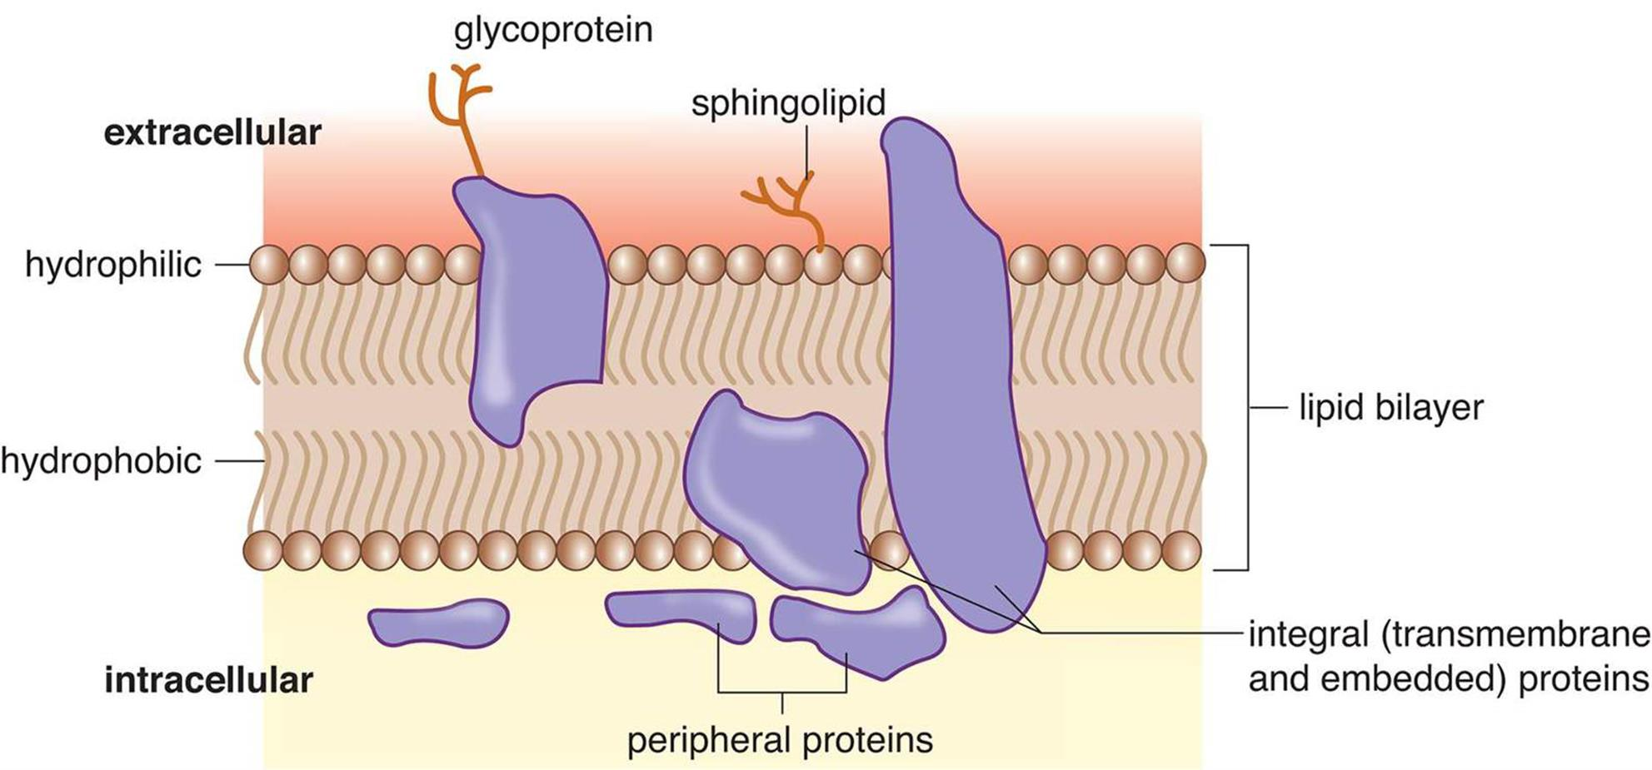

Carbohydrates

* Generally hydrophilic → interactions between glycoproteins and water can form a coat around the cell

Membrane Receptors

* Extracellular ligands can bind to membrane receptors, which function as channels or enzymes in second messenger pathways

Cell-Cell Junctions

* Regulate transport intracellularly and intercellularly

1. Gap junctions: intercellular junctions that provide cytoplasmic channels between adjacent cells.
2. Tight junctions (think watertight): intercellular junctions that prevent the movement of solutes within the space between adjacent cells.
   1. In blood capillaries, neighboring endothelial cells form tight junctions with one another to restrict the diffusion of harmful substances and large molecules into the interstitial fluid surrounding the brain.
3. Desmosomes: intercellular junctions that function as anchors to form strong sheets of cells.
4. Intercalated discs: specialized intercellular junctions between cardiac muscle cells that provide direct electrical coupling among cells.

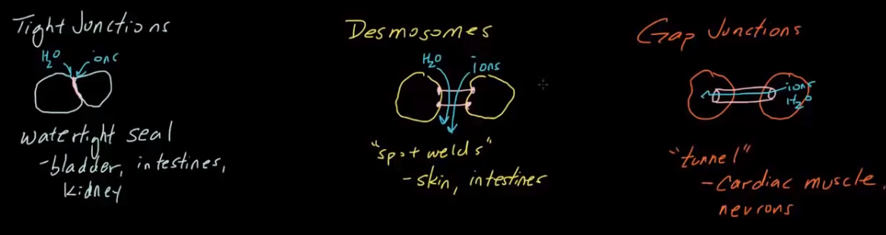

**8.3 Membrane Transport\***

Concentration Gradients

1. Passive transport (ΔG < 0)
   1. The primary thermodynamic motivator is the increase in ΔS
   2. The rate generally increases as temperature increases
2. Active transport (ΔG > 0)
   1. Active transport may or may not be affected by temperature, depending on the enthalpy ΔH of the process

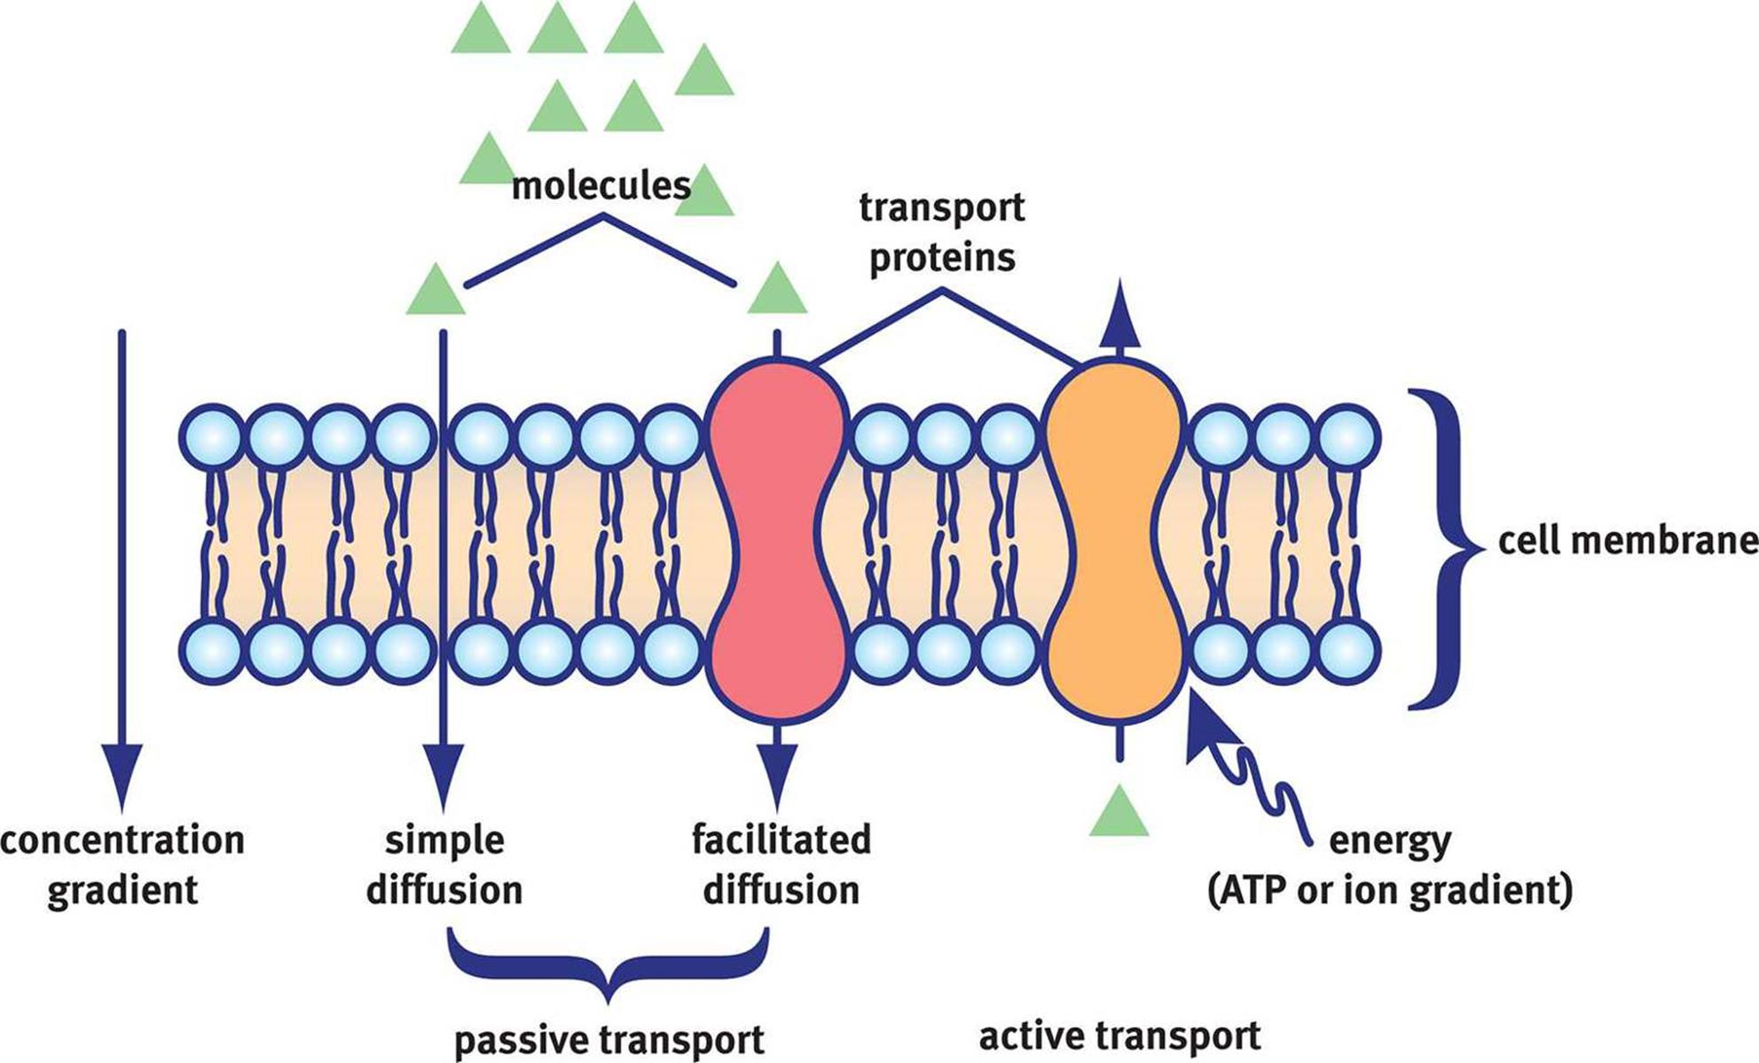

Passive Transport

1. Passive transport
   1. Simple diffusion
   2. Osmosis (specific kind of simple diffusion that concerns water)
      1. Osmotic pressure (a colligative property) = the pressure applied to a pure solvent to prevent osmosis and is used to express the concentration of the solution
      2. Better conceptualized as a “sucking” pressure applied to a pure solvent to prevent osmosis and is used to express the concentration of the solution
2. Facilitated transport

Active Transport

1. Primary active transport
   1. Uses ATP or another energy molecule to directly power the transport of molecules across a membrane
2. Secondary active transport
   1. Also known as coupled transport
   2. No direct coupling to ATP hydrolysis; instead, harnesses the energy released by one particle going **down** its electrochemical gradient to drive a different particle **up** its gradient
   3. If both particles flow in the:
      1. Same direction: symport
      2. Opposite direction: antiport

Endocytosis and Exocytosis

1. Endocytosis = engulfing material into cells via cell membrane
   1. Pinocytosis = endocytosis of fluids and dissolved particles (drinking)
   2. Phagocytosis = ingestion of large solids such as bacteria (eating)
2. Exocytosis = releasing material to the exterior of cells via cell membrane

**8.4 Specialized Membranes**

Membrane Potential

* Maintained by the sodium-potassium pump and leak channels
  + The pump maintains a low concentration of sodium ions and high concentration of potassium ions intracellularly by pumping 3 Na+ out for every 2 K+ pumped in → removes one positive charge from the intracellular space of the cell → maintains negative resting potential of cell
  + There are also leak channels that allow passive flow of Na+ and K+ in and out of the cell (note that cell membranes are more permeable to K+ because there are more K+ leak channels than Na+ leak channels)
* Electric potential created by one ion can be calculated using the Nernst equation
* Resting potential of a membrane at physiological temperature can be calculated using the Golman-Hodgkin-Katz voltage equation, which is derived from the Nernst equation

Mitochondrial Membranes

1. Outer membrane
   1. Highly permeable to metabolic molecules and small proteins
2. Inner membrane
   1. Surrounds the mitochondrial matrix (recall citric cycle and ETC)
   2. Does not contain cholesterol